PREPERATION
At least 2-3 square feet of floor space must be provided per broiler after 21 days of age. This space requirement is a must because it will affect the broilers uniformity, fleshing, finish, quality and cleanliness of the birds. After the house has been provided, then one must clean and disinfect the broiler house. Also, the waterers, feeders and feed pans must be cleaned before the broilers arrive.
A good method for cleaning is to use a garden hose sprayer and wash down with soap and water. After the house is dry, a disinfectant needs to be sprayed all in the house at a rate of ½ ounce per gallon of water. The disinfectant needs to be applied until the inside of the house until it is drenched, then it needs to dry.
Two days before the birds arrive, have the house ready with feed and water set up along with heat sources turned on. The next step is to put down some type of bedding material. The bedding must be soft and absorbent to help keep the broilers clean. 3-6 inches of good litter (ie. Pine shavings, rice hulls or peanut hulls) must be put down and a couple of inches added every other week to help prevent problems from occurring.
VENTILATION is very important. Proper ventilation will help prevent respiratory problems and other problems associated with poor ventilation.
Most broilers are grown using 24 hours of light. One or two 40-watt bulbs hung over the pen is adequate. Heat lamps usually supply all the light you need. Once removed, provide another source of light.
BROODING
The brooding stage is one of the most important times in a broiler’s life span. A brooder guard must be constructed to keep chicks near feed, heat and water. Cardboard or plastic that is taped in a circle works well as a brooder; the brooder should be a minimum of 18” high and 5 feet in diameter for 50 chicks. Some use kiddie pools or cut-cardboard zip-tied together.
To help keep the broilers near feed and water the brooder circle may be increased in size after 7 days, instead of removing completely. Also, once the chicks have full freedom of the pen, the corners should be rounded off to help keep the broilers from bunching up in corners.
TEMPERATURE
Maintaining the proper temperature in a broiler house can be the biggest difference maker in raising a quality set of broilers. If the birds are too hot they eat but don’t grow. If kept too cool, they may get sick. Electric heat lamps or brooders are good heat sources for brooding chicks. Make sure the lamps are secure so they cannot fall and start a fire. The lamps should hang so that the bottoms are 18-24 inches from the floor. Place waterers and feeders close enough to the heat lamp so that the chicks can easily reach them. Place the waterers far enough away to prevent water splashing on the bulbs.
Two 125-watt infrared bulbs are recommended depending on the temperature. Always use two lamps in case one burns out. A light with a red finish can be used to dull the light and reduce picking. Change the brooding temperature by adjusting the height of the heat lamp above the litter. Raising the lamps 3 inches will usually drop the temperature about 5 degrees.
Increased ventilation helps keep birds from being too warm. Contented chicks are often active and chirp softly and peacefully; while cold, uncomfortable, or sick chicks vocalize loudly with a shrill peep, huddle together, and act listless. Do not tire new chicks with excessive handling and stirring. Allow a minimum of 2 hours undisturbed time four times a day followed by 8-10 hours or more undisturbed night time rest in the first week.
An excellent method to check the temperature is to purchase a cheap round face outdoor thermometer and place directly on the shavings (because this represents the actual temperature where the birds are located).
Temperature should be as follows:
1st week……………………………..90-95 degrees Fahrenheit
2nd week…………………………….80-85 degrees Fahrenheit
3rd week…………………………….70-75 degrees Fahrenheit
4th week-show…………………..60-70 degrees Fahrenheit
***Don’t worry about colder temperatures during winter unless temperature drops below freezing once the birds are fully feathered out (usually around week 3)
A good visual appraisal of what the temperature is and how it is affecting the chicks is:
Too cold…………………..chicks huddled together
Too hot…………………….chicks spread out on outside of heat source
Normal…………………….chicks are scattered throughout the pen
Provide all-natural light for broilers, 24 hour lighting improves feathering and increases weight, plus allows the chicks the opportunity to eat all the time.
Supplemental heat may be needed in cold weather, however don’t keep the birds too warm once they are feathered out completely.
FEEDING
When the chicks arrive and you start putting them in the brooder circle, the first thing you should do is introduce each chick to water by dipping their beak in water then dip their beak in the feed, so they will know where the food and water is in the brooder circle.
All broilers should be able to eat at once. One pie or cookie pan for feed and a one-gallon waterer per 25 chicks are needed the first seven days. About after 2-3 weeks, consider feeding from a tube feeder that can be easily adjusted as the birds grow. One tube type feeder and one dual wall waterer is needed per 15-25 broilers. A rule of thumb is that the feeder height should be about the height of the back of the bird when it is standing upright. Dry feed should be available at all times. Shortly before arrival, a 3 or 4 foot square piece of light colored cotton cloth (such as a bed sheet) may be placed over the litter under the heat lamps to help prevent chicks from eating the litter.
In a proper brooder set-up, the tube feeders should be positioned like spokes of a wheel radiating out lengthwise from the edge of the heat lamp shields toward the brooder ring. Thus, the chicks can feed where they are comfortable and are not prevented by the feeders from moving toward the heat lamp if they become chilled.
Broilers respond to attention. Walk among broilers and stir feed/birds as often as possible. This will provide exercise and increase feed consumption and growth.
Another way to stimulate feed intake is to give the birds small amounts of feed that have been moistened with water, milk, or cooking oil.
Chicks can be started on a high protein (27-30%) turkey or game bird starter to stimulate growth. Feed the higher protein for a week or two, then switch to the broiler starter for a two to three-week period. After 4 weeks, they may be fed an 18-20% grower feed.
Waterers should be placed one between each feeder at the edge of the heat zone. Two 1-quart jars work well the first week if cleaned and refilled each morning and evening. After that, use 2 one-gallon waterers for the next three weeks. Feed and water can become too hot for the chicks to eat and drink. If it is too warm when touched with your wrist, it is too warm for them to eat. Waterers should be rinsed twice daily and scrubbed twice weekly. Add 2 or 3 tablespoons or up to ¼ cup of sugar per gallon (some recommend only for the first day) to lukewarm water. Dip each chick’s beak into the prepared water when you get them. Let the chicks drink first for at least one hour before offering them feed. To help them find water on their own, try putting a few shiny marbles in the trough of the waterer to attract their attention. Never let them run out of water.
After an hour or so, feed. You can scatter some feed on the cloth allowing them to walk on it thus locating it and starting to eat sooner. Watch carefully for the first hour or two to be sure they are finding the water and beginning to eat.
Chicks will need at least 4 linear inches of feeder space from 2-4 weeks of age. From then on allow 6 inches per bird.
Some exhibitors add 2 tablespoons of apple cider vinegar per 1 gallon of water once a week.
During the last two weeks before show, you may want to use a supplemental feed to stimulate feed intake and increase growth. Small amounts of broiler feed simply moistened with water or milk and cooking oil and fed several times during the day will stimulate older birds to eat more and increase gain.
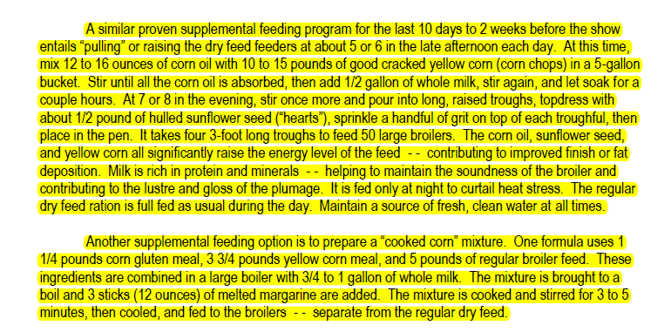
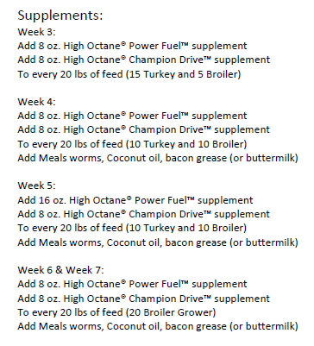
CULLING
Broilers should be culled continually. Small sick, stunted, deformed or crippled birds should be removed when detected. Reduce flock size at 21 days of age by removing the smaller and poorer fleshed birds. Keep three broilers for each one to be shown (13-15 birds). Cull at 35 days by weight and width of breast (6-8 birds). Fleshing, uniformity and finish will be improved by the increase in floor space and feeder space and the reduction in social pressure.

CALENDER
Day 1
-a light should be on in the pen all the time, a 40-watt is big enough.
-a radio is also a good idea. The noise helps the birds calm down and get them used to a variety of noise levels that a show provides
-95 degrees is the ideal temperature for baby chicks
-mix a ½ cup of sugar per gallon of water and use for three days
Dip beak of chick into water then feed then release under the brooder.
Day 7
-remove burlap or sheet and start expanding brooder circle or remove completely.
-provide all the fresh water the birds will drink, fresh water is extremely important.
-Chicks consume 10# of water per 1# of feed and will not gain as fast if they consume less water.
Day 10-14
-Change feed over to broiler starter/grower, start change by mixing starter crumbles with turkey starter crumbles for three days.
Day 21
-Cull by weight and feel to at least 3-4 birds per bird shown. Read show rules and know if you can show roosters, they are always heavier than the pullets, but sometimes don’t make a desirable show bird. After culling by weight, make sure all the remaining birds are long keeled. Remove small, sickly birds or birds that are slab-sided or short breasted. REMEMBER get rid of all culls so there is no competition for heat, space or air.
Day 22
-Introduce broiler finisher (pellets if available) to birds.
-Some feeders start “grease feeding” at this point. Introduce grease by adding 8 ounces to 1 ¼# of finisher feed. The grease should be cooked animal fat, not corn oil or cooking oil. Bacon grease, sausage, hamburger or any grease of that type works well, as long as it is fried or cooked to obtain. This gives it flavor. Feed the mix of grease and feed two times per day until day 28. Add this on top of the feed in the feeder so that the birds will eat both. Ten to fifteen trips a day to the chicken house is not too much. Birds respond to human contact.
Day 28
-Cull again by removing any birds that don’t match what is in the pen. Add an additional grease feeding to three times per day.
Day 35 to show or last seven days
-Grease feed six to eight times per day or as much as they will consume.
-two days before the show add ½ cup of sugar to 1 gallon of water each water change.
Show day or Selection day
- Select three birds as much alike as possible. Pick your best group of three. Do not try to second-guess a judge or sacrifice meat for uniformity. Three average birds will not beat two good birds with one average bird at any show. Do your best to not mix sexes within pens, plus some shows have separate pullet and rooster shows. Get checked in as soon as possible. Bring a couple of 1# coffee cans for water and feed in pen.

